**GOV31 Dog Permit Policy**

|  |  |  |  |
| --- | --- | --- | --- |
| **Policy owner** | Alpine Resorts Victoria | | |
| **Adopted by** | Alpine Resorts Victoria | | |
| **Adoption date** | 30/01/2025 | Scheduled review date | 30/01/2026 |
| **Version number** | 1.3 | Annual review | |

1. **Purpose**

The Alpine Resorts Victoria Management Board (the Board) is the land manager for the Mt Baw Baw Alpine Resort and is responsible for administering the Alpine Resort (Management) Regulations 2020.

The Regulations state that dogs cannot be brought into an alpine resort unless the Board has issued a current dog permit (authority) and the conditions set by the Resorts are adhered. Cats are not permitted under any circumstances.

The dog permit system assists the Board to comply with:

* Managing risks to public safety, hygiene, and threats to native wildlife;
* Delivering the Resorts’ Environmental Management Plan action plan of the endangered Baw Baw Frog and management of the vulnerable or rare flora and fauna species;
* Delivering year-round predator (wild dog, feral cat, fox) monitoring and control program and protect permitted dogs by implementing controls to keep them safe;
* Maintaining good relationships with residents, stakeholders and visitors by having a fair and transparent permit allocation and enforcement system.

1. **Scope**

To outline the eligibility criteria for a dog permit, application process, dog permit conditions and penalties for breach of conditions.

The Board expects all dog permit holders and anyone responsible for their dog to know and understand the dog permit policy. Ignorance of the dog permit policy or dog permit conditions is not a defence against enforcement action.

1. **Dog permit eligibility**

*Residents and staff*

A permanent resident year-round or full-time seasonal (declared snow season only) member of the resort team may apply for an annual dog permit valid from 1 June to 31 May. A dog permit will not be issued for one-off, short, or temporary stays in the Resort.

The eligibility criteria are:

1. Payment of the annual application fee.
2. The applicant must be either:

* A permanent member of the resort management team, who is required for work purposes to reside on resort for extended periods of the year in accommodation that is separated from other staff, or;
* A permanent resident in the Resort.

1. Evidence of the dog’s Council registration confirming where the dog resides outside the

Resorts and the dog’s name, sex, breed and whether it is de-sexed.

No preference or weight is placed on previously approved dog permits or legacy arrangements.

*Other Purposes*

Dog permit eligibility will also be considered in the following circumstances.

* Registered Tour Operators delivering experiences, tours and activities to visitors involving dogs, e.g. dog sled tours.
* Event Organizers and event participants when associated with an approved Event, e.g. dog sled dash event, or
* Contractors who use a working dog, as part of an approved environmental conservation program, e.g. Baw Baw Frog detection program

Permit exemptions apply for a person visiting the Resorts with a certified guide and therapy dogs on active duty.

Permit exemptions apply for a member of an emergency services organisation (VicPol, SES, etc) with a registered dog on active duty, e.g. for search and rescue, drug and substance search.

1. **Application process**

Application forms are available by request via emailing [permits.mtbawbaw@alpineresorts.vic.gov.au](mailto:permits.mtbawbaw@alpineresorts.vic.gov.au). A permit will not be automatically renewed.

Applications will be processed within 2 weeks of receiving all the required information. Permits will be issued from the date the completed application including ALL supporting evidence is received and payment is made in full. Applications received after 15 May will not be guaranteed approval prior to the declared snow season.

A dog permit will be sent by email and must be issued prior to a dog’s entry to the Resorts. Alternatively, a dog permit can be posted.

The application process must be approved by the Authorised or Accountable Officer.

1. **Dog permit conditions**

The following conditions apply to all resident dog permits:

1. Dogs must:
2. Remain indoors and supervised at all times, exceptwhen being taken on walks or going to the toilet in the resort.
3. Be suitably toilet trained and the accommodation nominated must be equipped with a receptacle or device for the use of the dog indoors. All associated waste must be disposed of in tied bags.
4. Be on a lead at all times when outdoors.
5. Not be left tied up in public spaces.
6. Wear the identifiable Resort lead (or tag) at all times and the owner must carry a dog waste carry bag holder when outdoors.
7. Not be taken in Resort vehicles or village shuttle services.
8. Wear council registration tag at all times.
9. Permit holders or a person responsible for a permitted dog must:
10. Have effective control of the dog at all times when outdoors.
11. Avoid danger or unreasonable disturbance to other persons or wildlife or interference to property.
12. Clean up and properly dispose of all dog excrement in tied bags.
13. Only walk a dog on village streets and Beech Trail unless participating in work or an event (see Section 7) and not take a dog into:
14. Any food and beverage venue or other building property, including alpine dingo designated area.
15. The ski area including lift loads/unloads (summer or winter) or on non-designated trails.
16. Provide their permit or name and accommodation upon request from any Board officer or Resort staff member identifiable by uniform.

The Board reserves the right to set additional conditions on a case-by-case basis as it deems necessary.

1. **Penalties for breach of conditions**

The Board may cancel a dog permit, issue an infringement notice and/or refuse to accept future dog permit applications if there is a breach of the dog permit conditions under Section 22 and 23 of the Regulations.

Please note:

1. No warning notices will be provided. The Board expects all dog permit holders and anyone responsible for their dog to be aware of and comply with the dog permit policy and dog permit conditions.
2. Where a dog is responsible for disturbance or injury to wildlife or property or unreasonable disturbance to other persons, it will result in the immediate cancellation of the dog permit and removal of the dog from the Resorts, at the owner’s own cost.
3. Any dog removed from the Resorts via compliance/enforcement activities where an owner cannot be identified or is not present will be transported and delivered to the neighbouring council dog pound at either Baw Baw Shire or Murrindindi Shire.
4. **Designated dog walking area**

Resident dogs may only be walked or carried on the trails shown below. Dogs are not permitted in the ski field areas or on other trails not identified in the map below Unless participating in work or a pre-organised event:

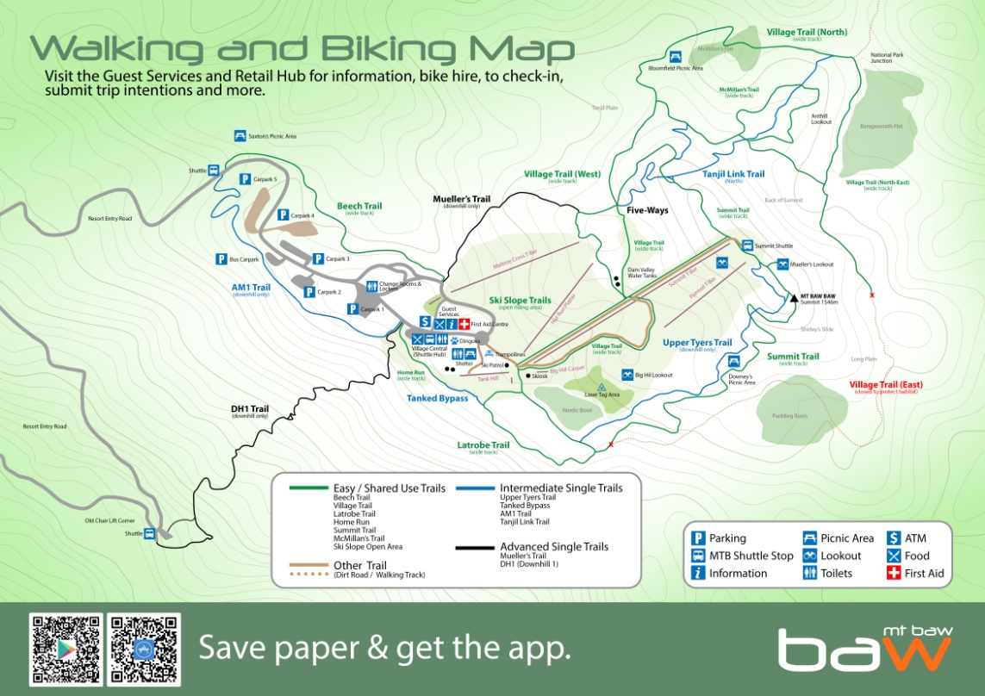

**Approved dog walking areas:** sealed roads or tracks where dogs may be walked.

1. **Disputes**

Disputes or grievances regarding this policy are to be settled pursuant to the *PEO22 Managing Workplace Complaints and Grievances Procedure*.

The Board reserves the right to vary, replace or terminate this policy from time to time. This policy does not form part of any employee’s contract of employment.

**Appendix 1 – Dog Permit Declaration**

**DOG PERMIT APPLICATION**

The applicant must be either:

1. A permanent member of the resort management team, who is required for work purposes to reside on resort for extended periods of the year in accommodation that is separated from other staff, or;
2. A permanent resident in the Resort.

|  |  |  |  |  |  |
| --- | --- | --- | --- | --- | --- |
| **Applicant Name:** |  | **Email:** |  | **Phone:** |  |
|  | **Dog 1** | **Dog 2** | **Dog 3** | **Dog 4** | **Dog 5** |
| **Name:** |  |  |  |  |  |
| **Gender:** |  |  |  |  |  |
| **Dogs breed:** |  |  |  |  |  |
| **Microchip #** |  |  |  |  |  |
| **Council registration number:** |  |  |  |  |  |

|  |  |  |  |  |  |
| --- | --- | --- | --- | --- | --- |
| **Applicant Name:** |  | **Email:** |  | **Phone:** |  |
|  | **Dog 1** | **Dog 2** | **Dog 3** | **Dog 4** | **Dog 5** |
| **Name:** |  |  |  |  |  |
| **Gender:** |  |  |  |  |  |
| **Dogs breed:** |  |  |  |  |  |
| **Microchip #** |  |  |  |  |  |
| **Council registration number:** |  |  |  |  |  |

**DECLARATION**

I confirm that I, and any person with responsibility for my dog, is aware of and understands the dog permit policy and agree to abide by the following dog permit conditions:

The following conditions apply to all dog permits:

* 1. Dogs must:

1. Remain indoors and supervised at all times, exceptwhen being taken on walks or going to the toilet in the resort.
2. Be suitably toilet trained to use a receptacle or device to collect and dispose of waste in tied bag.
3. Be on a lead at all times when outdoors.
4. Not be left tied up in public spaces.
5. Wear the identifiable Resort lead (or tag) at all times and dog waste carry bag holder when outdoors.
6. Not be taken in Resort vehicle or village shuttle services.
7. Wear council registration tag at all times.
   1. Permit holders or a person responsible for a permitted dog must:
8. Have effective control of the dog at all times when outdoors.
9. Avoid danger or unreasonable disturbance to other persons or wildlife or interference to property.
10. Clean up and properly dispose of all dog excrement in a tied bag.
11. Only walk a dog on village streets and Beech Trail (see Section 7) and not take a dog into:

* Any food and beverage venue or other building property, including alpine dingo designated area.
* The ski area including lift loads/unloads (summer or winter) or on non-designated trails.

1. Provide their permit or name and accommodation upon request from any Board officer or mountain staff member identifiable by uniform.

I, and a person responsible for my dog, acknowledge that:

1. A breach of any dog permit conditions may result in the dog permit being cancelled, an infringement notice being issued or a refusal to issue future dog permits.
2. No warning notices will be provided. The Board expects all dog permit holders and anyone responsible for their dog to be aware of and comply with the dog permit policy and dog permit conditions.
3. Where a dog is responsible for disturbance or injury to wildlife or property or unreasonable disturbance to other persons, it will result in the immediate cancellation of the dog permit and removal of the dog from the Resorts, at the owner’s own cost.
4. Any dog removed from the Resort via compliance/enforcement activities where an owner cannot be identified or is not present will be transported and delivered to the neighbouring council dog pound at either Baw Baw Shire or Murrundindi Shire.

Name of dog owner

*Office Use Only*

*Approval: Y / N\**

*Signature of Authorised/Accountable officer*

Signature of dog owner

*\*Office Use Only - Further comment for non-approval:*

Applicant notified: (____/____/____)

The above declaration must be completed and returned to the Board by email to: [permit@mtbawbaw.com.au](mailto:permit@mtbawbaw.com.au). ***Dog permits will not be issued if this declaration is not returned.***